Patty

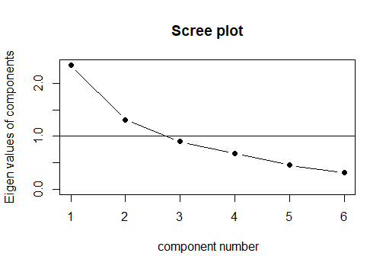

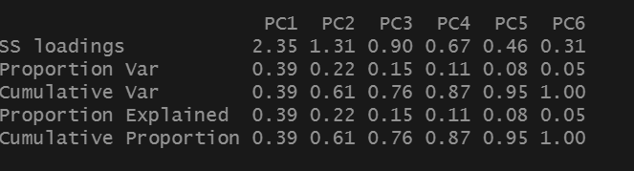

From scree plot, we choose 3 factors. Because 2 factors only account for 61% cumulative variance and 3 factors has 76% although the wigenvalues of 3 factors is negative but it is closer to 1 than 2 factos.

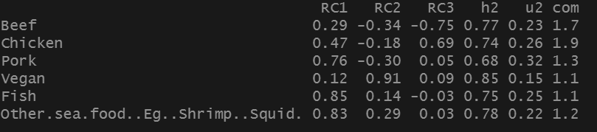

1st factor is the one who likes seafoods, 2nd factor is the one who like vegan, 3rd is the one who like beef but not chicken or the other way round.

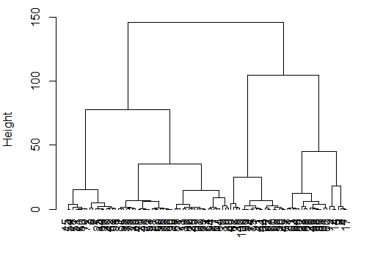

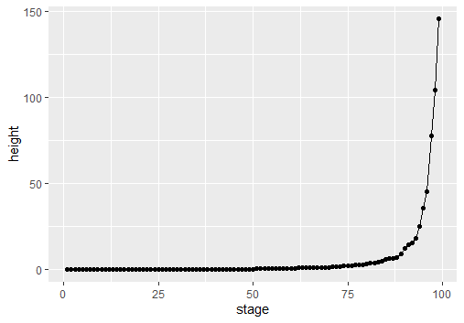

We choose 5 cluster. (reason)

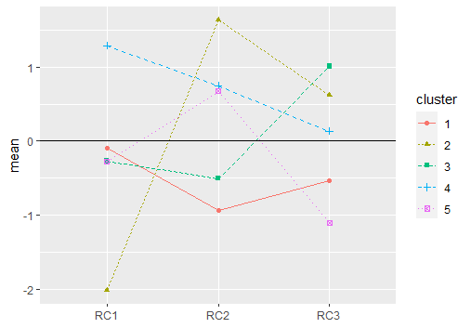

Cluster 1 are the one who prefer meats. Cluster 2 is vegetarian. Cluster 3 is religious as its 3rd factor is highest which have to choose between beef and chicken. Cluster 4 meat seafood lover. Cluster 5 healtier people who have large portion of vege in meals.

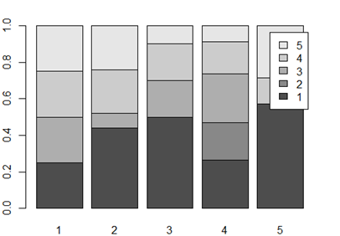

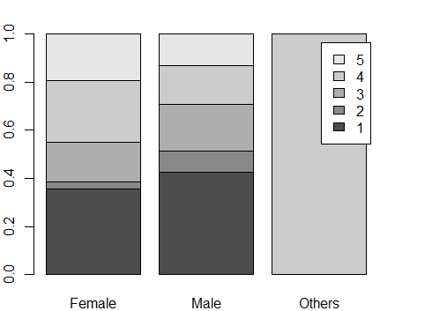

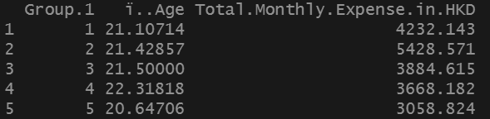

Since group 1 is meat lover which spends higher than others except group 2. Group 2 is vegetarian and since vegetarian foods are higher price than others due to nutrition control so this group spend the most.

Sauces

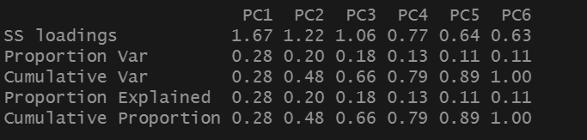

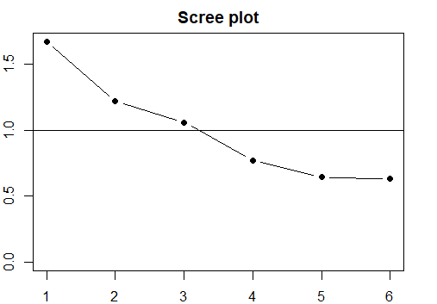

We choose 3 factors due to the scree plot where the eigenvalue is close to 1 at 3 although its cumulative variance is only 66%.

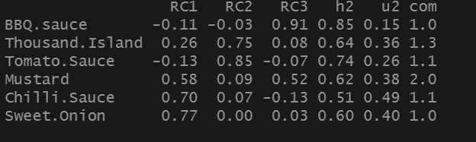

1st factor likes strong spices. 2nd likes sour. 3rd likes smoked bbq.

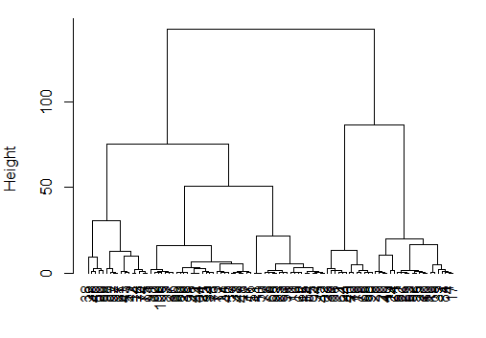

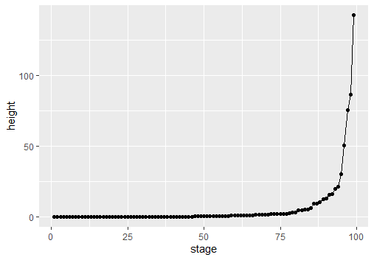

We choose 5 clusters.

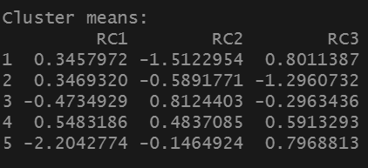

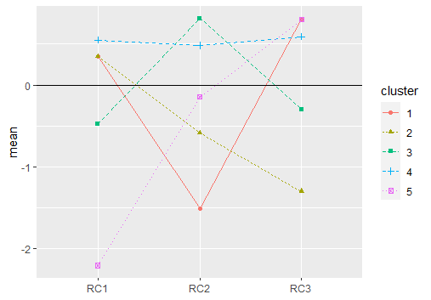

Cluster 1 dislike sours. Cluster 2 likes strong taste with different sauce. Cluster 3 likes sour taste. Cluster 4 good with any sauces. Cluster 5 only likes BBQ sauces.

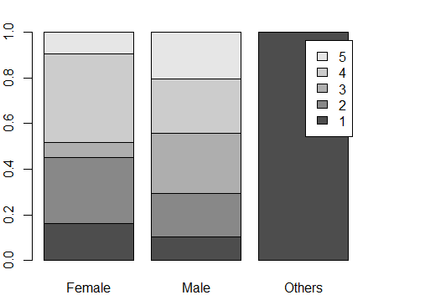

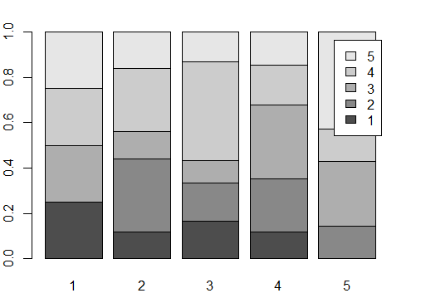

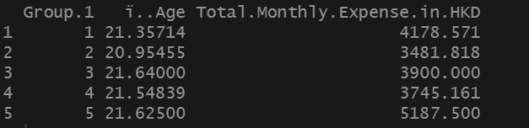

Cluster 5 like bbq sauces who spent the most as bbq sauce is expensive in market. Cluster 1 likes every thing except sours sauce which make it second largest expense group.

Services

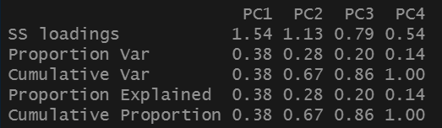

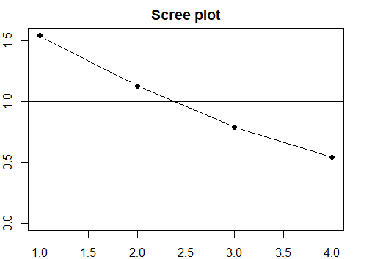

We choose 2 factors.

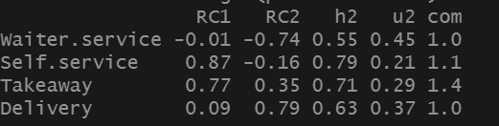

1st factor is independent. 2nd is relying.

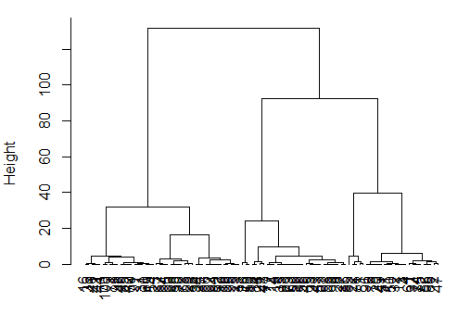

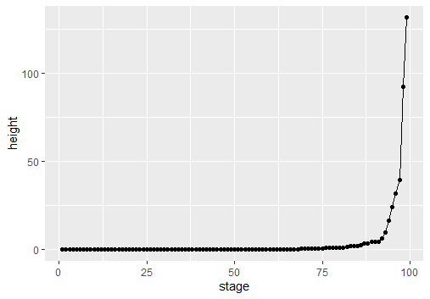

We choose 2.

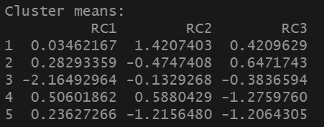

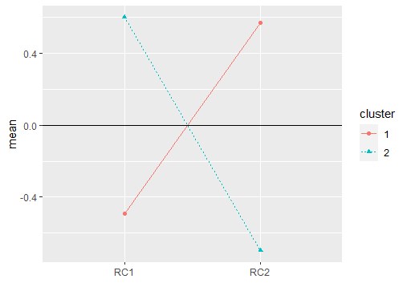

Cluster 1 is lazy people who need waiters to serve and delivery service. Cluster 2 is independent people who likes to order themselves and come and pick up their own food.

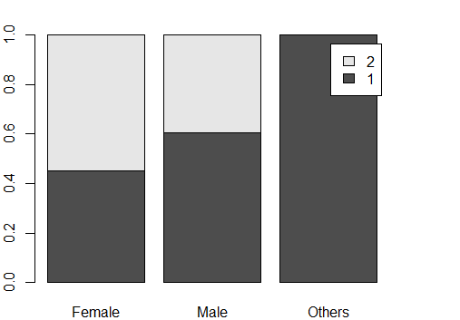

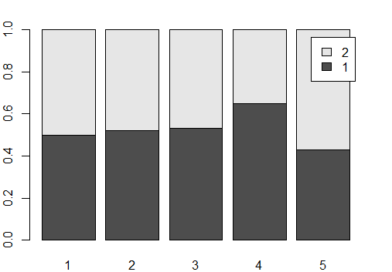

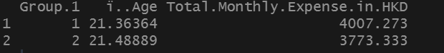

Group 1 pay higher for waiter and delivery services.

Side_dish

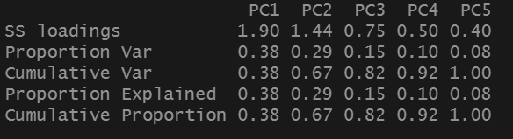

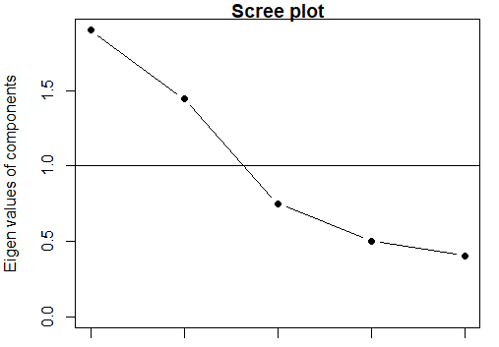

We choose 3 factors since cumulative proportion is 82%.

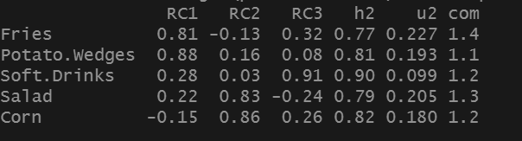

1st factor is fried food. 2nd is healthier salad and corn. 3rd is soft drink.

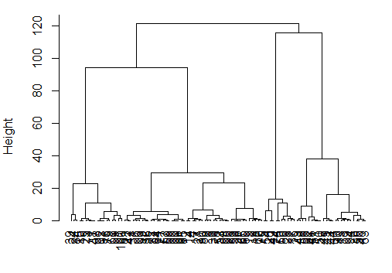

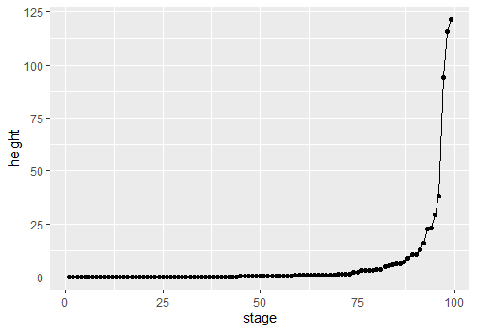

We choose 5.

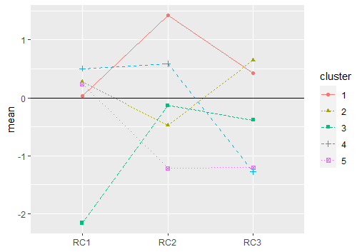

Cluster 1 healthy people factor 2 highest. Cluster 2 likes set food. Cluster 3 doesn’t like side_dish. Cluster 4 balanced life. Cluster 5 unhealthy.

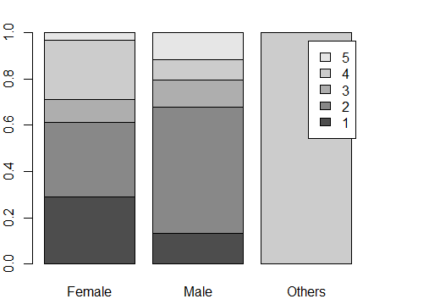

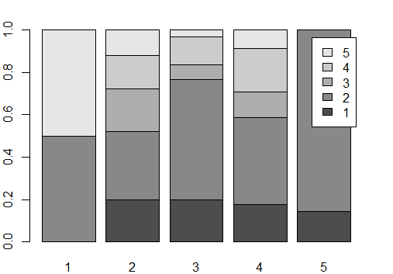

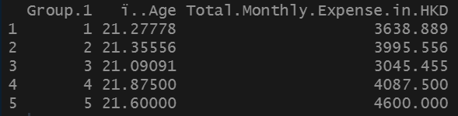

Cluster 5 unhealthy so spend most on the expensive food in side dish – fried food. Cluster 4 balanced life so have high expense. Cluster 2 like combination with drinks so spend high also.

Location-preference

